EXP.NO:5
DATE:27.03.2025
USER INTERFACE DESIGN
Roll no: 230701244
Praveen R
AIM:
To conduct a task analysis for a E commerce and document the userflow diagram using Lucidchart.

Content:
- Task Analysis - Write down task breakdowns
- User Flows - Create fowcharts for each task (Lucidchart)

Task Analysis for E-Commerce Flowchart
1. Start Process
- The user initiates the process.
2. Create Document
- The user creates a document, which likely refers to setting up an order, an account, or another essential record.
3. Select Template
- The user selects a predefined template, which might be related to order categories or account setup.
4. Add Details (Diverging into Multiple Flows)
- The process splits into three primary flows:
  - Login Flow
  - Search
  - Checkout

Login Flow
- Open App – The user opens the application or platform.
- Process – The app initializes, loads data, or processes a request.
- Enter Details – The user enters login credentials (email, phone, password, etc.).
- Login – The system authenticates the user.
- Verify – Additional security measures may be applied (OTP, 2FA).
- Redirect Home – Upon successful login, the user is redirected to the home page.

Search Flow
- Navigate Categories – The user browses different product categories.
- Use Search Bar – The user enters keywords to search for specific products.
- Apply Filters – Filters like price range, brand, and ratings are applied to refine search results.

Checkout Flow
- Review Cart – The user views selected items in the shopping cart.
- Proceed to Checkout – The user confirms their selection and moves forward.
- Enter Shipping Info – The user provides an address and delivery details.
- Select Payment Method – The user chooses a payment method (credit card, UPI, etc.).
- Confirm Order – The order is placed successfully.

Lucid Diagram:

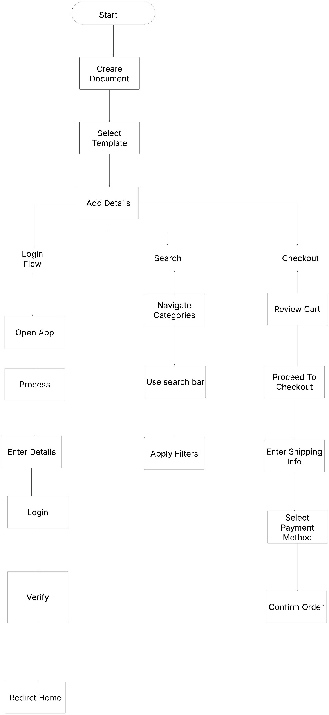

The link of my lucid chart :

https://lucid.app/lucidchart/35e99c13-28d8-4e58-835d-fafbf92bf40c/edit?viewport_loc=-7197%2C-981%2C24735%2C10969%2C0_0&invitationId=inv_dfb6b625-6488-481f-9fdd-a41ff52e9b17

